How to use StudentGrouper

The student grouper software is designed to help group a set of students using their preferences for other students to be in the same group. This document outlines how the software works and how the end user can interact with it to get the output.

# Step 1: Prepare the student input csv file

First the students need to be in a format that can be read by the software. This format is a comma separated value (CSV) that contains 10 columns.

Each row defines a student, and each column represents a piece of information about this student.

This CSV can be constructed in Microsoft Excel and then converted to CSV afterwards, so it is suggested that Excel is used to form this list.

The columns must be in order and contain meaningful data, otherwise the program will not be able to read it. The columns are, in order:

1. Students first name
2. Students middle name
3. Students family name
4. The students unique id (not this must only contain numbers from 0-9)
5. Rows 5-10 are the unique ids of the students that this student has selected that they want to be in the same group as. This can be in any order, and again must only have numbers from 0-9 in each column

An example of this data can be seen in mockCsvInput.csv inside the packaged folder.

Now that this document has been saved, in Excel go to either File->Export->CSV or File->Save As->CSV

# Step 2: Start StudentGrouper.exe

Double click on StudentGrouper.exe to start the application. It should look something like the image below.

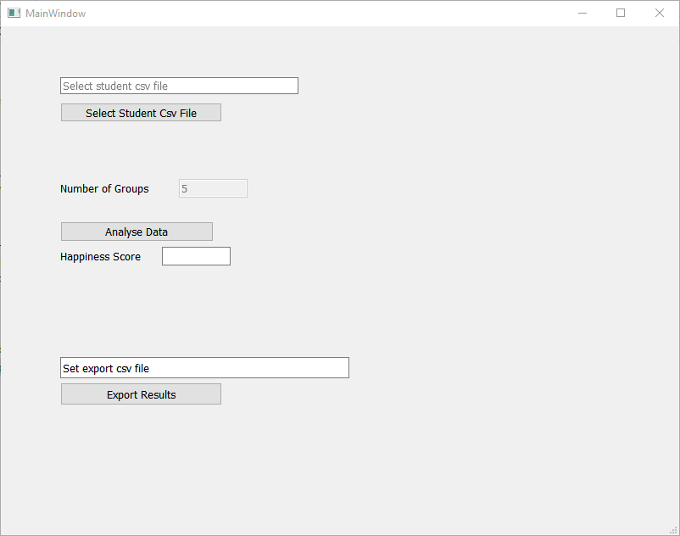

First click on ‘Select Student Csv File’ and select the Csv file that you saved in Step 1.

Then click ‘Analyse Data’. After a few seconds have passed the Happiness Score will be populated and the analysis of the students will be done.

Finally, to get these results, click ‘Export Results’ and name and save the Csv file.

# Step 3: View and analyse the data

Once the result Csv has been created, open this up in Excel again. This will show 5 columns with a row for each student.

First, save this file as an excel document, instead of Csv by going File->Save As.

Then you can analyse the grouping performed by the app. The column meanings are as follows:

1. The first column is the group number, from 1 to 5.
2. The second column is the student’s unique id number
3. The third column is the students first name
4. The fourth column is the students first name
5. The fifth column is the students first name

# Final Remarks

Hopefully this guide helped you understand and use the software.

This is a very rough system that has many flaws, but is hopefully able to help create a starting point for grouping the students.

If there are any suggestions, such as group size, or the input or output csv format, please get in contact and we will try to do what we can to help.